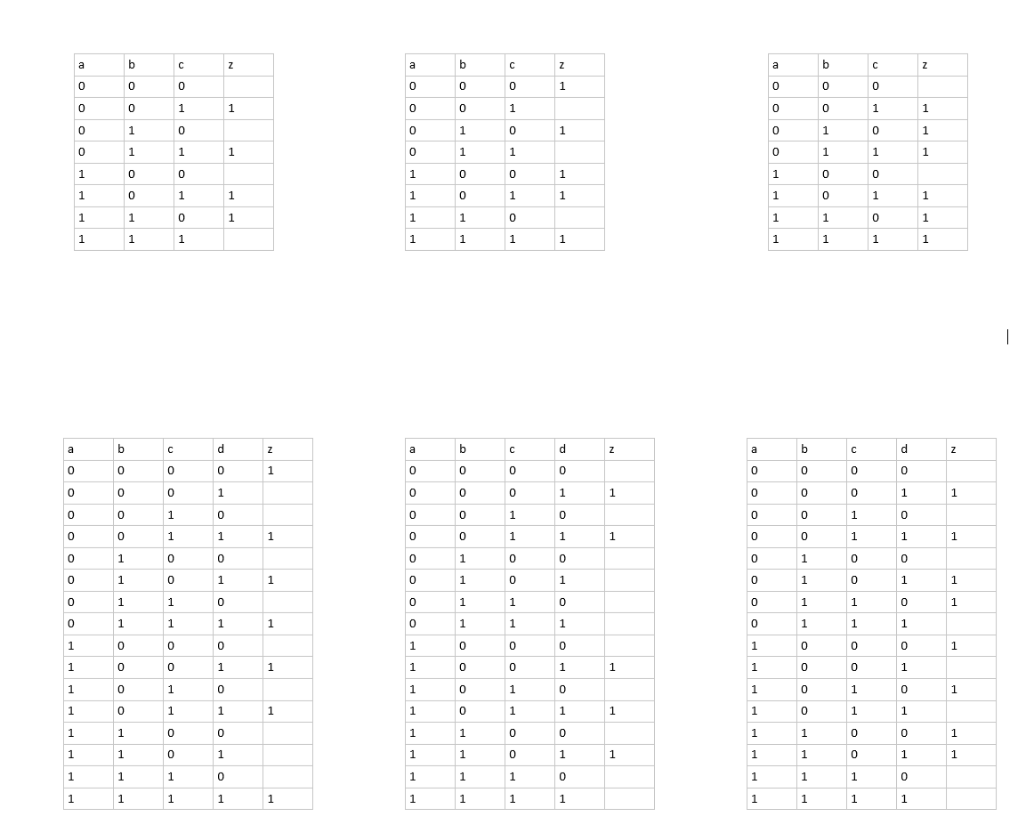

Z = (nA ^ nB ^ C) v ( nA ^ B ^ C) v (A ^ nB ^ C) v (A ^ B ^ nC)

Z = [(nA ^ C) ^ (nB v B)] v [(nB ^ C) ^ (nA v A)] v (A ^ B ^ nC)

Z = (nA ^ C) v (nB ^ C) v (A ^ B ^ nC)

Z = (nA ^ nB ^ nC) v (nA ^ B ^ nC) v (A ^ nB ^ nC) v ( A ^ nB ^ C) v (A ^ B ^ C)



Z = [(nA ^ nC) ^ (nB v B)] v [(nB ^ nC) ^ ( A v nA)] v [(A ^ C) ^ (nB v B)]



Z = (nA ^ nC) v (nB ^ nC) v (A ^ C) oder Z = (nA ^ nC) v ( A ^ nB) v (A ^ C)



Z = (nA ^ nB ^ C) v (nA ^ B ^ nC) v (nA ^ B ^ C) v ( A ^ nB ^ C) v (A ^ B ^ nC) v (A ^ B ^ C)

Z = [(nA ^ C) ^ (nB v B)] v [(B ^ nC) ^ ( A v nA)] v [(A ^ C) ^ (nB v B)]

Z = (nA ^ C) v (B ^ nC) v (A ^ C)

Z = [C ^ (nA v A)] v (B ^ nC)

Z = C v (B ^ nC) = (C v B) ^ (C v nC)

Z = C v B

Z = (nA ^ nB ^ nC ^ nD) v (nA ^ nB ^ C ^ D) v (nA ^ B ^ nC ^ D) v (nA ^ B ^ C ^ D) v (A ^ nB ^ nC ^ D) v (A ^ nB ^ C ^ D) v (A ^ B ^ C ^ D)



Z = (nA ^ nB ^ nC ^ nD) v {(nA ^ C ^ D) ^ (nB v B)} v {(nA ^ B ^ D) ^ (nC v C)} v {(A ^ nB ^ D) ^(nC v C)} v {(A ^ C ^ D) ^ (nB v B)}

Z = (nA ^ nB ^ nC ^ nD) v (nA ^ C ^ D) v (nA ^ B ^ D) v (A ^ nB ^ D) v (A ^ C ^ D)

Z = (nA ^ nB ^ nC ^ nD) v (nA ^ C ^ D) v (nA ^ B ^ D) v (A ^ nB ^ D) v (A ^ C ^ D)Z = (nA ^ nB ^ nC ^ nD) v {(C ^ D) ^ (nA v A)}v (nA ^ B ^ D) v (A ^ nB ^ D)

Z = (nA ^ nB ^ nC ^ nD) v (C ^ D) v (nA ^ B ^ D) v (A ^ nB ^ D)

Z = (nA ^ nB ^ nC ^ D) v (nA ^ nB ^ C ^ D) v (A ^ nB ^ nC ^ D) v (A ^ nB ^ C ^ D) v (A ^ B ^ nC ^ D)

Z = {(nA ^ nB ^ D) ^ (nC v C)} v {(A ^ nB ^ D) ^ (nC v C)} v {(A ^ nC ^ D) ^ (nB v B)}

Z = (nA ^ nB ^ D) v (A ^ nB ^ D) v (A ^ nC ^ D)

Z = {(nB ^ D) ^ (nA v A)} v (A ^ nC ^ D)

Z = (nB ^ D) v (A ^ nC ^ D)

Z = (nA ^ nB ^nC ^ D) v (nA ^ nB ^C ^ D) v (nA ^ B ^nC ^ D) v (nA ^ B ^C ^ nD) v (A ^ nB ^nC ^ nD) v (A ^ nB ^C ^ nD) v (A ^ B ^ nC ^ nD) v (A ^ B ^ nC ^ D)

Z = [(nA ^ nB ^ D) ^ (nC v C)] v [(nA ^ nC ^ D) ^ (nB v B)] v ~~[(A ^ nC ^ nD) ^ (nB v B)]~~ v [(A ^nB ^ nD) ^ (nC v C)] v [(A ^ B ^ nC) ^ (nD v D)] v (nA ^ B ^ nC ^ D)

Z = (nA ^ nB ^ D) v (nA ^ nC ^ D) v ~~(A ^ nC ^ nD)~~ v (A ^nB ^ nD) v (A ^ B ^ nC) v (nA ^ B ^C ^ nD)